WEB TASARIM ÖDEVİ



SAKARYA ÜNİVERSİTESİ

Buğra Başaran G211210015

|  |
| --- |
| **HAKKIMDA** |
| **CV** |
| **ŞEHRİM** |
| **MİRASIMIZ** |
| **İLGİ ALANLARIM** |
| **LOGİN** |
| **İLETİŞİM** |

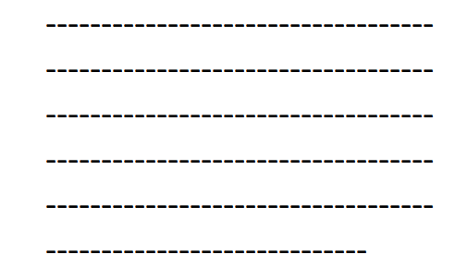

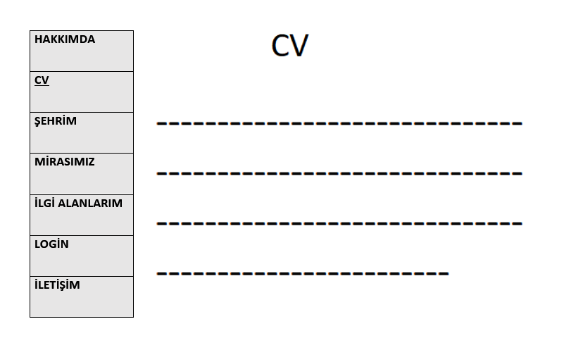

|  |
| --- |
| **HAKKIMDA** |
| **CV** |
| **ŞEHRİM** |
| **MİRASIMIZ** |
| **İLGİ ALANLARIM** |
| **LOGİN** |
| **İLETİŞİM** |

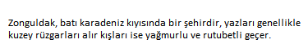

|  |
| --- |
| **HAKKIMDA** |
| **CV** |
| **ŞEHRİM** |
| **MİRASIMIZ** |
| **İLGİ ALANLARIM** |
| **LOGİN** |
| **İLETİŞİM** |

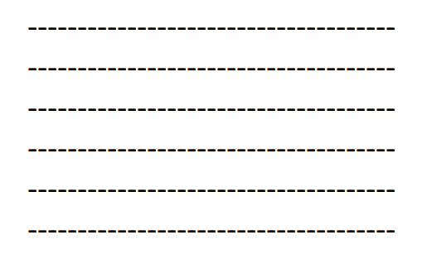



|  |
| --- |
| **HAKKIMDA** |
| **CV** |
| **ŞEHRİM** |
| **MİRASIMIZ** |
| **İLGİ ALANLARIM** |
| **LOGİN** |
| **İLETİŞİM** |

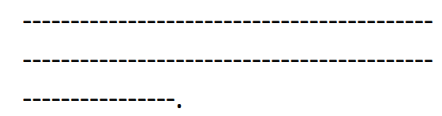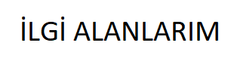

|  |
| --- |
| **HAKKIMDA** |
| **CV** |
| **ŞEHRİM** |
| **MİRASIMIZ** |
| **İLGİ ALANLARIM** |
| **LOGİN** |
| **İLETİŞİM** |

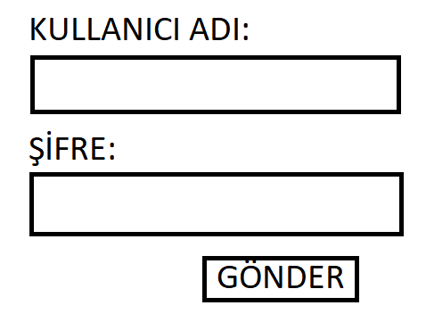

|  |
| --- |
| **HAKKIMDA** |
| **CV** |
| **ŞEHRİM** |
| **MİRASIMIZ** |
| **İLGİ ALANLARIM** |
| **LOGİN** |
| **İLETİŞİM** |

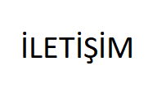

GİTHUB LİNKİM: https://github.com/basaraann/web-tasarim.git